**Activity: Interactive Problem Solving with Flowcharts**

Objective: The objective of this hands-on activity is to practice problem-solving skills and create flowcharts to visually represent the problem-solving process. Participants will work individually or in small groups to solve a given problem using a flowchart.

**Problem: "Planning a Weekend Getaway"**

You and your friends want to plan a weekend getaway to a nearby hill station. However, you need to consider various factors such as budget, transportation, accommodation, and activities to make the best decision. Use problem-solving techniques and create a flowchart to help guide your decision-making process.

ANSWER :-

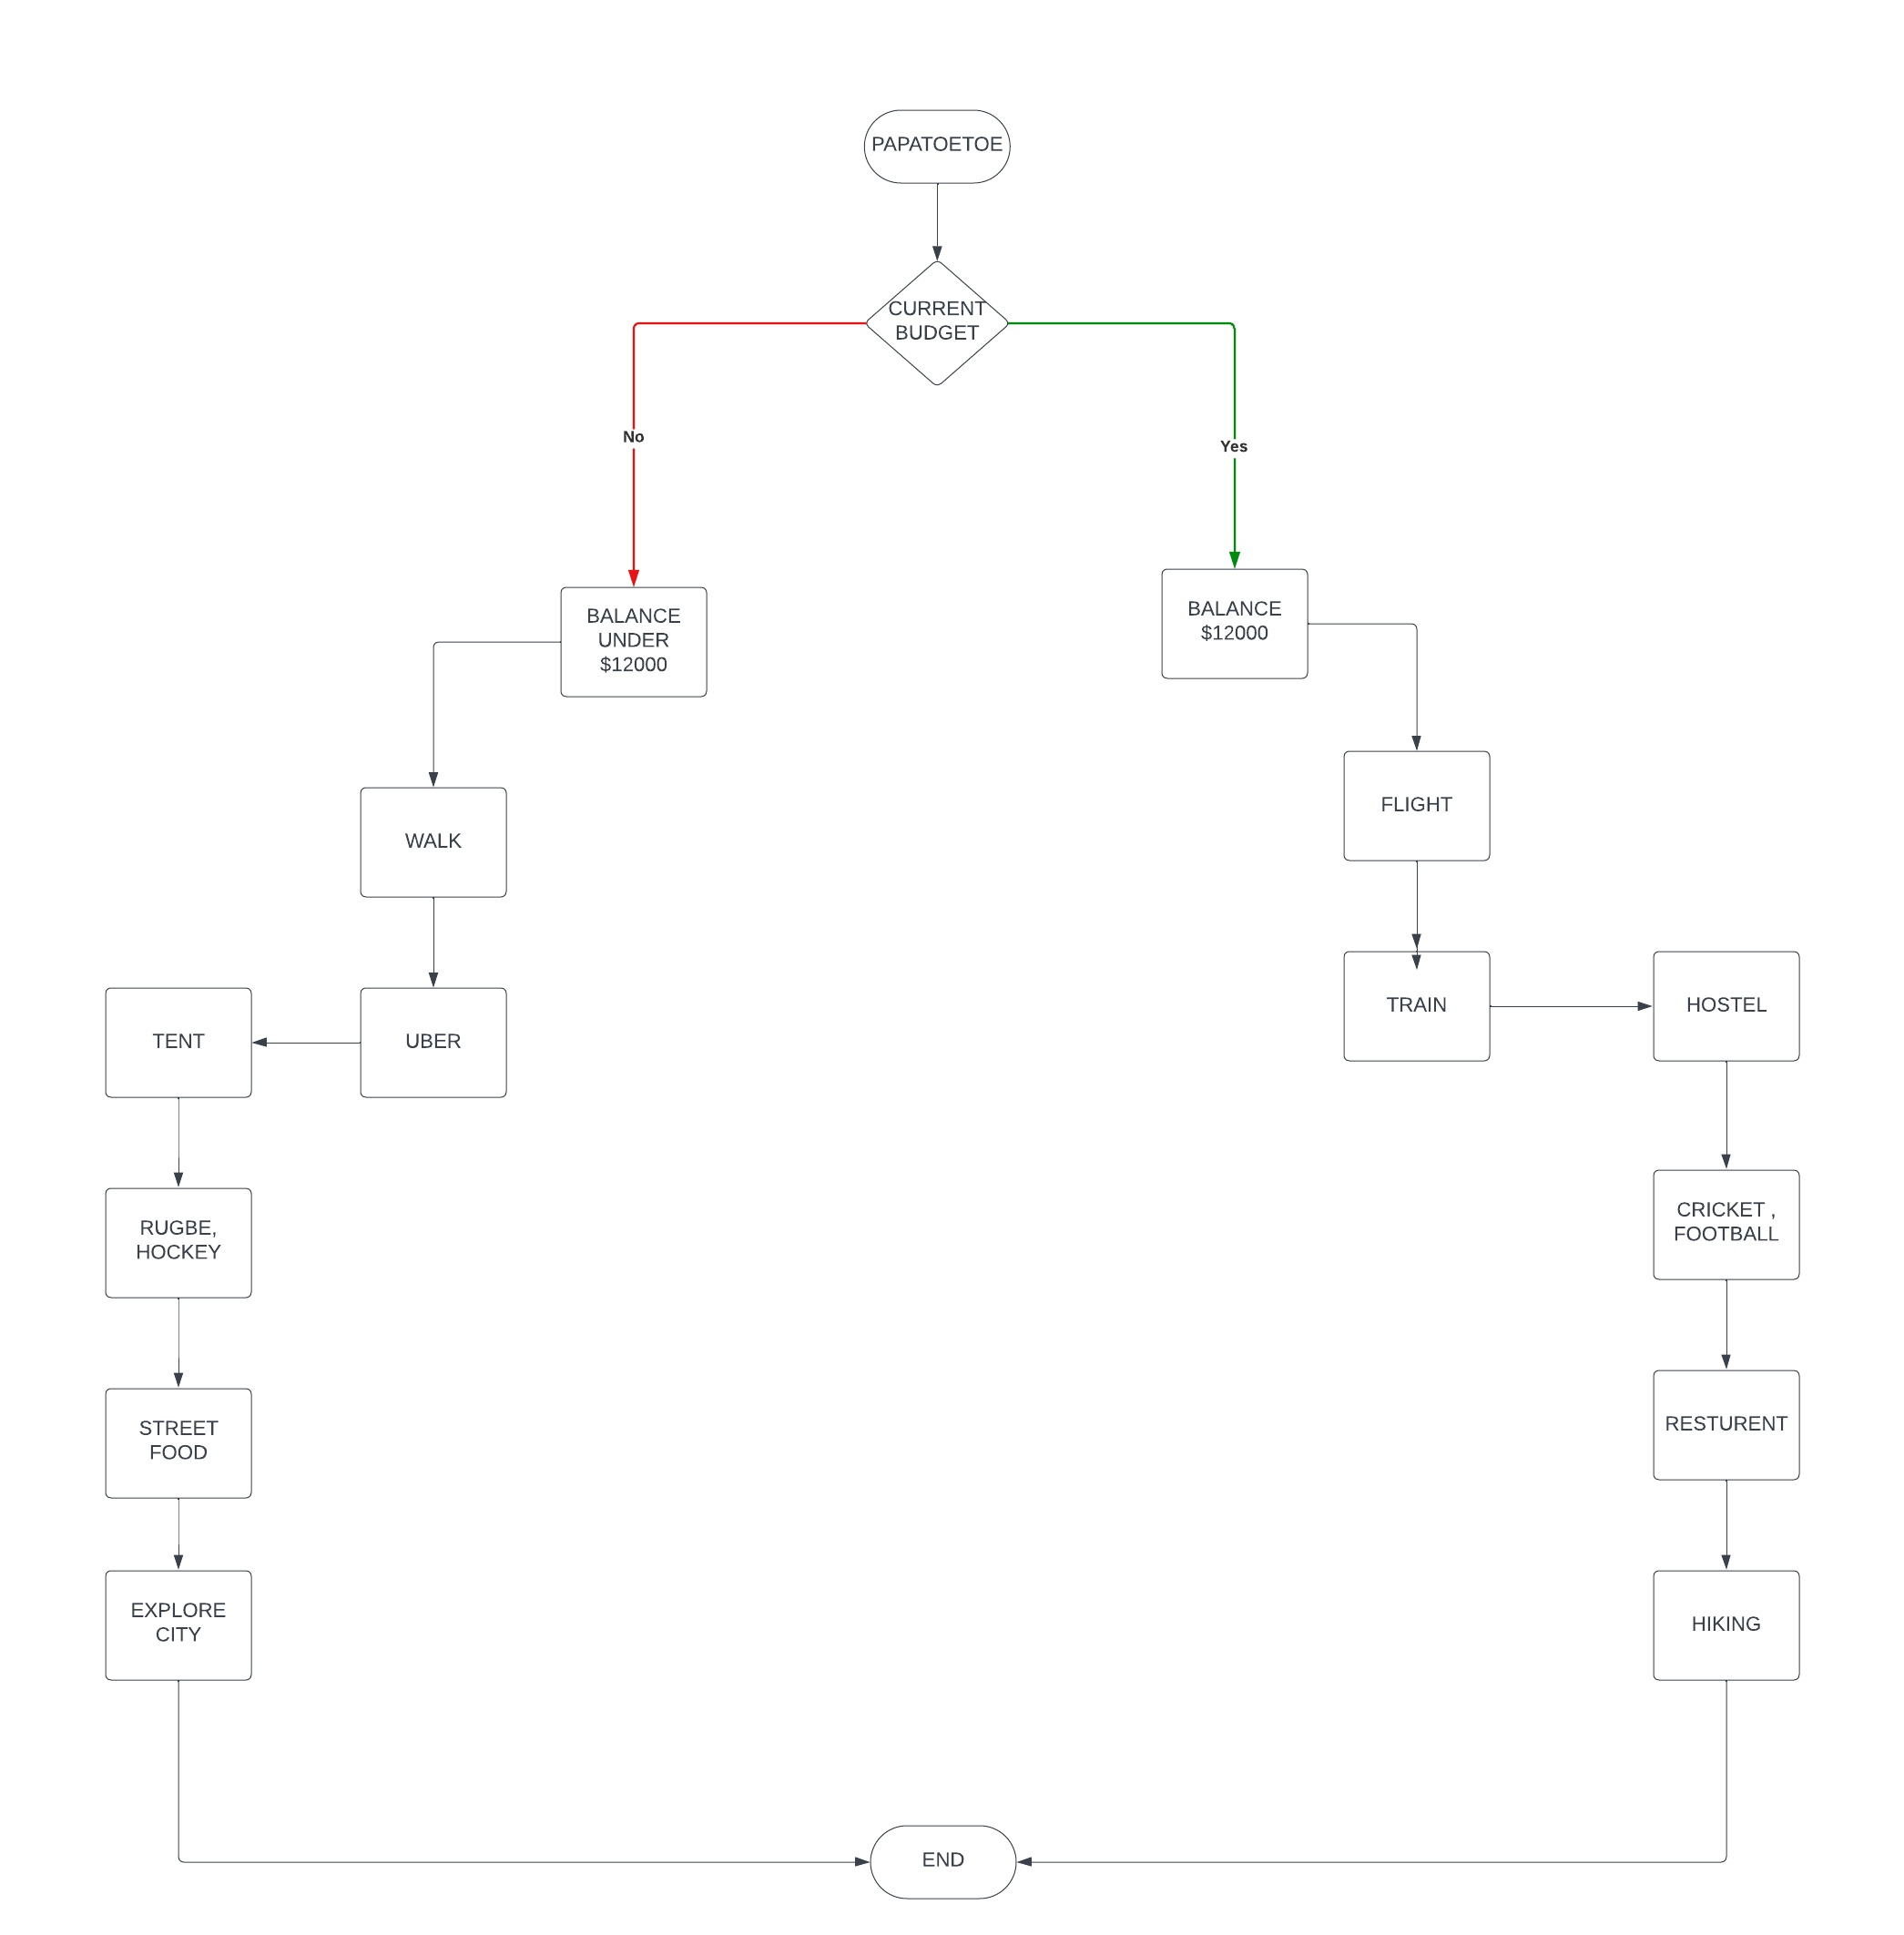

Pseudo-code for**"Planning a Weekend Getaway**

Pseudo-code for**"Planning a Weekend Getaway**

BEGIN PAPATOETOE

WE WILL CHECK OUR TEAMS BUDGET

IF THE BUDGET IS POCKET FRINDELY WE WILL BOOK HOSTEL IN ADVANCE AND BOOK TICKET OF A TRAIN OR FLIGHT MOREOVER WE WILL TRY DOING HIKING AND PLAY SOME GAMES LIKE FOOTBALL , CRICKET AND EAT SOMETHINH ON RESTURENT

ANOTHER OPTION IS TO STAY IN A TENT BY GOING THOURH WALK AND AFTER THAT WE WILL LIKE TO HAVE SOME FUN WITH RUGBE ANF HOCKEY AND EAT FOOD AND IN THE END LIKE TO EXPLORE THE CITY